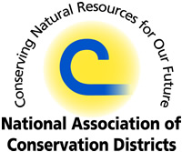
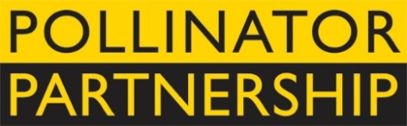
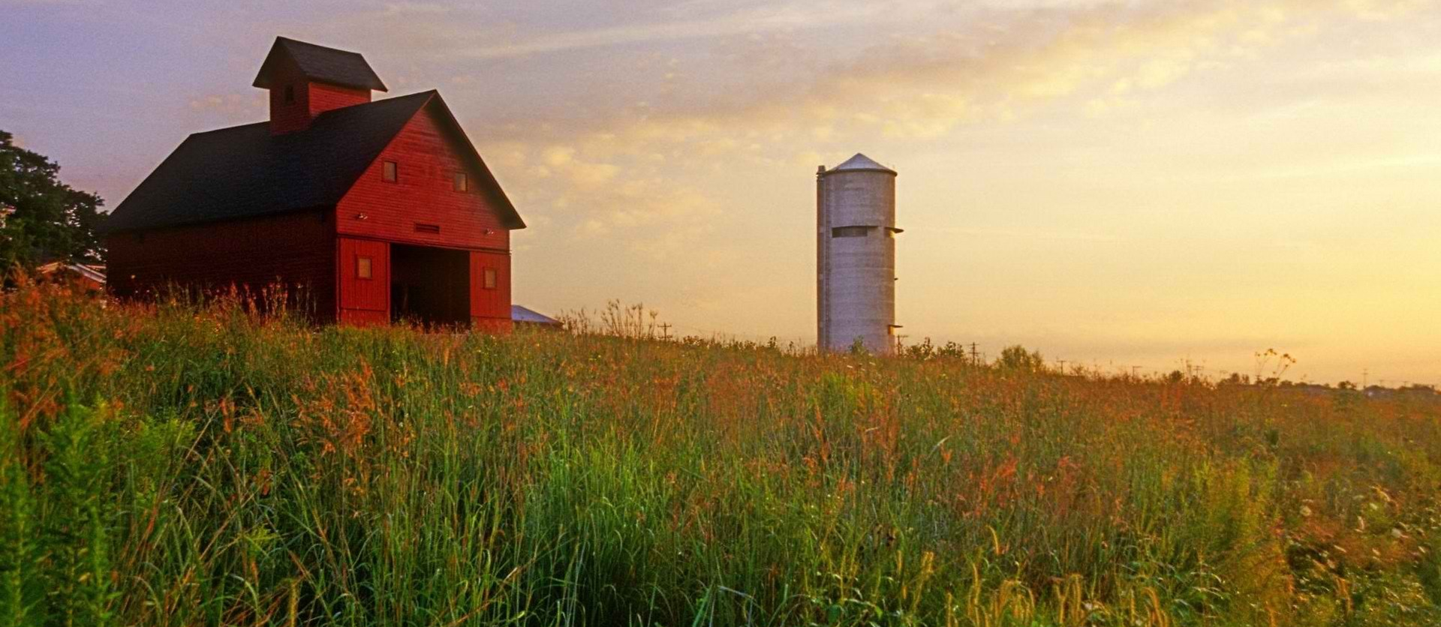
NAPPC Farmer-Rancher
Pollinator Conservation Award

The National Association of Conservation Districts (NACD) and Pollinator Partnership (P2) are pleased to solicit nominees for the 2017 Farmer-Rancher Pollinator Conservation Award, recognizing an individual or family in the farm and ranch community who has contributed significantly to pollinator species protection and conservation.
With pollinators providing one of three bites of food that we eat and nearly $16B to the US agricultural economy, care and concern for their survival is essential to our own survival. Pollinator Conservation Award winners support pollinators on their lands, engage in research and experimentation to increase our understanding of pollinator management techniques, work with community and government groups, and serve as advocates for these little, but hard-working, species that maintain our agricultural and natural landscapes.
The recipients of the 2017 award will be recognized during an evening reception that opens the 17th Annual North American Pollinator Protection Campaign Conference at the US Botanic Garden on Tuesday, October 17, 2017 from 6:00 pm to 8:00 pm in Washington, DC, or in their hometown if they are unable to attend.
Previous award winners include Lakhy Sran of Sran Family Orchards in California; Heikes Family Farm from Vermillion, SD; Josiah and Valer Austin of El Coronado Ranch and Cuenca de los Ojos; and Mark Wagoner of Wagoner Touchet Farms in Washington. Through recognition and appreciation of these individuals and organizations, we hope to encourage their conservation stewardship and catalyze future actions on behalf of pollinators. Visit http://www.pollinator.org/awards.htm to learn more.
To complete your nomination, please return the attached form to Vicki Wojcik at the Pollinator Partnership by deadline of Friday August 11, 2017. Awardees will be notified no later than Thursday August 31, 2017 to allow for travel arrangements.
Forms can be sent as an e-mail attachment to vw@pollinator.org (please put “Farmer-Rancher Pollinator Conservation Award” as the subject line) or faxed to 415-362-3070 or mailed to 423 Washington Street 5th floor, San Francisco CA, 94111.

Farmer-Rancher
Pollinator Conservation Award Nomination Form

Please return the attached form to Vicki Wojcik at the Pollinator Partnership by Friday August 11, 2017. Forms can be sent as an e-mail attachment to vw@pollinator.org (please put “Farmer-Rancher Pollinator Conservation Award” as the subject line) or faxed to 415-362-3070.

Supporter’s Information:
Name:
Organization, if applicable:
E-mail: Phone:

I wish to nominate the following individual or family in the farm and ranch community for the Farmer-Rancher Pollinator Conservation Award:
Nominee’s Name:
Farm/Ranch:
E-mail: Phone:

Nomination Narrative (Please provide a narrative or recommendation letter that speaks to the three points listed below. You may use this word document or attach separate sheets. Please keep submission at a maximum of 4 pages, not including and images or representative materials):

1. Briefly describe nominees and their farm or ranch operation (location, size, crop, community).

2. Describe the contributions of the individual or family farmer/rancher to pollinator protection and conservation on working and wild lands, including but not limited to “on-the-ground” pollinator conservation, best management practices, landscape management techniques, etc.

3. Describe the contribution of individual or family farmer/rancher to the development of conservation partnerships, research partnership, demonstration projects that promote pollinator awareness and conservation, community and social/political actions that promote and protect pollinators, etc.

