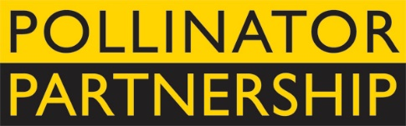
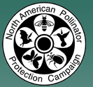
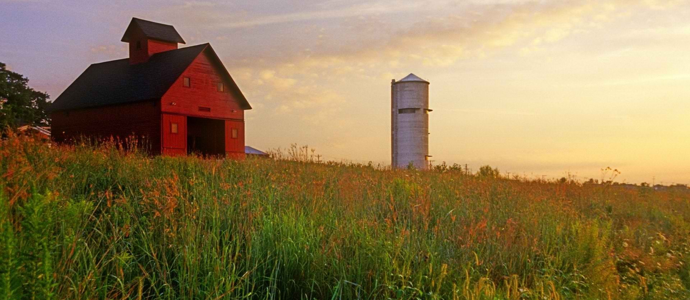
Pollinator Advocate Award

The North American Pollinator Protection Campaign (NAPPC) and the Pollinator Partnership (P2) are pleased to solicit nominees for the 2017 Pollinator Advocate Award, recognizing an individual or organization that has contributed significantly to pollinator species protection and conservation in Canada, the United States, and Mexico.
This award recognizes individuals and/or organizations that have contributed significantly to pollinator species protection and conservation and to public education resulting in increased awareness of the importance of pollination. NAPPC, through its recognition and appreciation of these individuals and organizations, encourages their activities and hopes to catalyze future actions on behalf of pollinators. All activities that contribute significantly toward pollinator conservation will be considered, including, but not limited to, on-the-ground projects, educational programs, development of policies and partnerships, research on pollinators, or management activities that promote pollinators. Please note: NAPPC partners are not eligible. You can submit more than one nomination.
The recipients of the 2017 award will be recognized during an evening reception that opens the 17th Annual North American Pollinator Protection Campaign Conference on Tuesday, October 17, 2017 from 6:00 pm to 8:00 pm in Washington, DC, or in their hometown if they are unable to attend.
Previous award winners include Bob McLean (Canada), Dan Ashe (USA), and Alejandro del Mazo Maza (Mexico). Through recognition and appreciation of these individuals and organizations, we hope to encourage their conservation stewardship and catalyze future actions on behalf of pollinators. Visit http://www.pollinator.org/awards.htm to learn more.
To complete your nomination, please return the attached form to Vicki Wojcik at the Pollinator Partnership by deadline of Friday August 11, 2017. Awardees will be notified no later than Thursday August 31, 2017 to allow for travel arrangements.
Forms can be sent as an e-mail attachment to vw@pollinator.org (please put “Pollinator Advocate Award” as the subject line) or faxed to 415-362-3070 or mailed to 423 Washington Street 5th floor, San Francisco CA, 94111.

Pollinator Advocate Award Nomination Form

Please return the attached form to Vicki Wojcik at the Pollinator Partnership by Friday August 11, 2017. Forms can be sent as an e-mail attachment to vw@pollinator.org (please put “Pollinator Advocate Award” as the subject line) or faxed to 415-362-3070.
My Name: _____________________________________________________________________
My E-mail:_________________________________________Phone:_______________________

I wish to nominate the following person or organization for the NAPPC Pollinator Advocate Award:

Nominee’s Name*:_______________________________________________________________
Title*:_________________________________________________________________________
Organization:___________________________________________________________________
Nominee E-mail*:___________________________________ Phone*:______________________

Nomination Narrative (Attach a separate sheet if needed or insert narrative into this document. If nominating an individual you may also attach a CV or resume. While we do want to learn as much as possible about each nominee, please restrict applications to a maximum of 4 pages):

1. Please provide some background information about the person or organization.

2. Describe or list the contributions of the person or organization to pollinator protection and conservation and/or public education to increase pollinator awareness.

3. Describe the impact that this person or organization has had on pollinator conservation locally, regionally, or globally.

