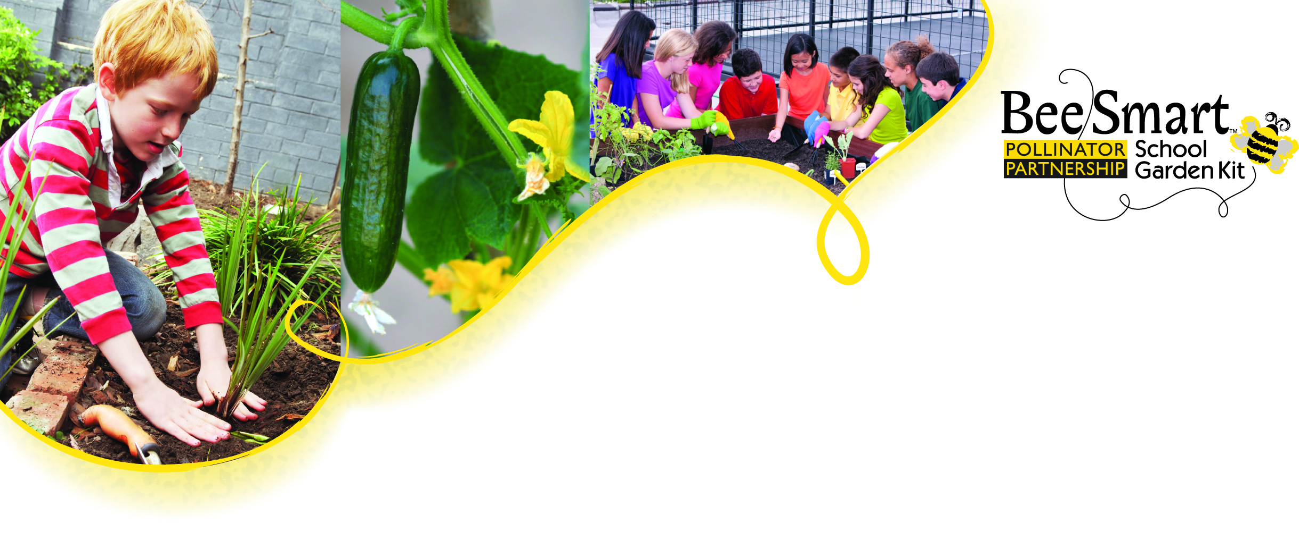
Lesson Plan 10
Bee Smart Snacks
™

Delicious Pollinated Treats!

Enjoy your pollinator-inspired snacks! Refer back to Lesson 4’s “Commonly Eaten Foods” handout. Consider pairing the snack portion of this lesson with fun optional educational extensions:

Optional extension 1: Before students are allowed to take/eat a snack, they have to try to name the pollinator that helped bring it to us. (ie. If there is a plate of fig newtons, the student would say “Wasps helped the figs to grow so we can have fig newtons.”)

Optional extension 2: In groups (one group for each snack item), have students create small signs or thank you cards for each snack telling the reader what pollinator(s) made it possible. (ie. “Thanks to the bees that brought us these strawberries.”)

Optional extension 3: Have students create their own recipe and bring in a snack for a potluck pollinator party to celebrate pollinators!

Simple Snacks
- Honey graham “sandwich” - honey graham crackers spread with cashew or almond butter topped with dried cranberries and chocolate chips
- Stuffed tomatoes - cherry tomatoes cut in half stuffed with cream cheese and chopped chives sprinkled with toasted sesame seeds
- Simple guacamole – mash 1 ripe avocado, sprinkle with salt and pepper, squeeze lemon juice and put a dollop on a cucumber slice and top with a piece of roasted red pepper
- Fruit salad – cut slices of apples, blueberries, grapefruit, kiwi, melons, orange, peaches, pears, and strawberries to create a healthy snack
- S’mores – honey graham crackers, chocolate, and marshmallows

Apiscotti (bee-enabled biscotti)
1/2 C butter
½ C sugar
¼ C honey
3 eggs
1/2 t salt
1 t almond extract
1/ 4 t nutmeg
2 t baking powder
21/2 to 3 C flour
1/2 C dried cranberries, chopped
1/2 C dried cherries, chopped
1/2 C blanched sliced almonds, chopped

Preheat oven to 350 degrees. Cream sugar and butter together; mix in honey until smooth. Beat eggs until frothy and then add salt, almond extract, nutmeg and baking powder. Combine sugar/butter mixture with egg mixture. Add flour until dough is a consistency that can be handled.

Refrigerate dough for one hour or more. Divide chilled dough into three parts and flatten each third into rectangles (use additional flour if needed).

Place in a line in the center of each flattened section of dough and fill with chopped cherries, cranberries, and nuts. Fold the sides of each rectangle over to form a loaf with filling in center and seal. Place loaves on greased cookie sheet at 350 degrees for 45 minutes to one hour or until golden brown. Slice on a slant while hot into 1/2 inch slices. For crispier slices, return to oven for 15-20 minutes or until golden-brown (the color of a honey bee).

Of the 12 ingredients in this recipe, 7 depend on the pollination services of Apis mellifera (butter, honey, almond extract, nutmeg, cranberries, cherries, almonds)—hence the name “Apiscotti.” Without Apis mellifera (European honey bee), breakfast (and every other meal) would be infinitely less interesting and colorful.

It’s not just honey! We can thank pollinators for giving us many of the ingredients we use to satisfy our sweet tooth. The Pollinator Partnership thanks Dr. May Berenbaum for sharing her original recipe with us.

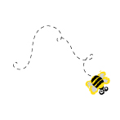
“I became acutely aware of the plight of pollinators as a result of chairing the National Academy of Sciences study on the status of pollinators a few years ago and have gained a new appreciation in particular of bees and ALL that they do for us, and I've been doing everything I can to raise awareness in the general public ever since….It's not hard to do -- honey bees, as you know, contribute on average to about one-third of what we eat and with Apiscotti, I just effortlessly upped the percentage. What was hard to do was to decide which honey bee-related items NOT to include in the recipe—there are so many delicious things that bees bring to our tables!” - May Berenbaum, Ph. D., Professor & Department Head, University of Illinois

Cranberry-Chocolate Tart (10 to 12 servings)
Thank you to Bon Appetit magazine for this recipe.

Cranberry Topping
½ cup cranberry juice, divided
1 teaspoon unflavored gelatin
1 12-ounce bag fresh or frozen cranberries
¾ cup sugar
2 teaspoons fresh lemon juice
1 teaspoon finely grated lemon peel
1 teaspoon grated peeled fresh ginger
Pinch of salt
4 tablespoons finely chopped crystallized ginger

Pour ¼ cup cranberry juice into small bowl; sprinkle gelatin over. Let stand until softened, 15 minutes. Combine ¼ cup cranberry juice, cranberries, and next 5 ingredients in medium saucepan; bring to boil, stirring until sugar dissolves. Reduce heat to medium; simmer until cranberries are tender but plump, 5 minutes. Strain into bowl; set cranberries aside. Add gelatin mixture to hot juice in bowl; stir until gelatin dissolves. Stir cranberries back into juice. Chill until cranberry mixture is cold and slightly thickened, at least 8 hours or overnight.

Do Ahead: Can be made 2 days ahead. Cover and chill. Stir chopped crystallized ginger into cranberry mixture.

Crust
1 ¼ cups chocolate wafer cookie crumbs (made from about 6 ½ ounces cookies, finely ground in processor)
¼ cup sugar
1/8 teaspoon salt
5 to 6 tablespoons unsalted butter, melted

Position rack in center of oven and preheat to 350 degrees F. Combine chocolate wafer cookie crumbs, sugar, and salt in medium bowl; add 5 tablespoons melted butter and stir until crumbs feel moist when pressed together with fingertips, adding remaining 1 tablespoon melted butter if mixture is dry. Press crumb mixture firmly onto bottom and up sides of 9-inch-diameter tart pan with removable bottom. Bake chocolate crust until beginning to set and slightly crisp, pressing with spoon if crust puffs during baking, about 14 minutes. Transfer tart pan to rack and cool crust completely before filling.

Marscapone Filling
1 8-ounce container marscapone cheese
½ cup powdered sugar
½ cup chilled whipping cream
1 teaspoon vanilla extract
Thin strips of crystallized ginger (optional garnish)
Using electric mixer, beat all ingredients except ginger in medium bowl just until thick enough to spread (do not overbeat or mixture may curdle). Spread filling in cooled crust.

Do Ahead: Can be made 1 day ahead. Cover and Chill.
Spoon cranberry mixture evenly over marscapone filling. Chill at least 2 hours and up to 6 hours. Garnish with crystallized ginger strips, if desired. Cut tart into wedges and serve cold.

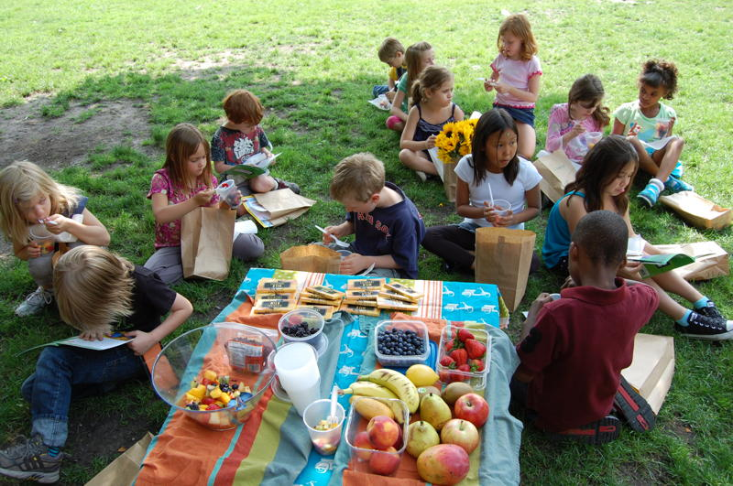
Photo: Anastasia Hinchsliff

